**Name:Salma Rani**

**Sap_id:54194**

**Web lab submission**

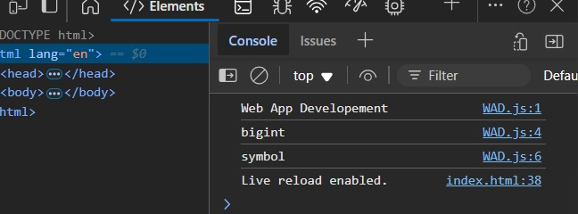**TASK 1**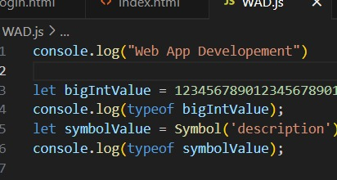

**TASK 2**

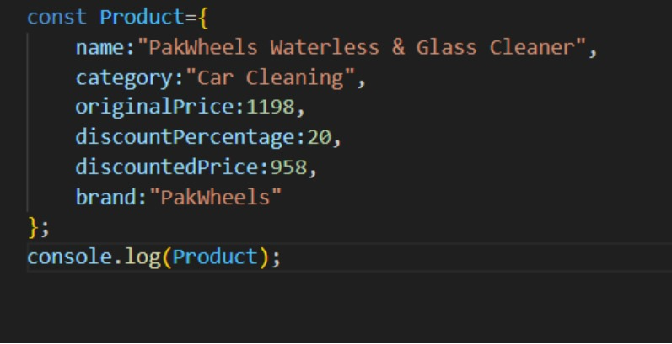

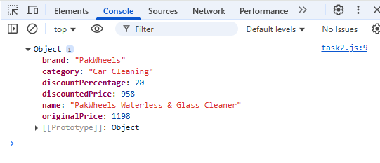

**TASK 3**

const InstagramProfile={

    username:"SalmaRani_1",

    name:"Salma Rani",

    posts:0,

    followers:64,

    following:617,

    bio: {

        religion:"Muslim",

        nationality:"Pakistani",

        profession:"Nutritionist",

        interest: "White lover"

    },

    followedBy: ["aliax123", "saira12", "6 others"],

};

console.log(InstagramProfile);

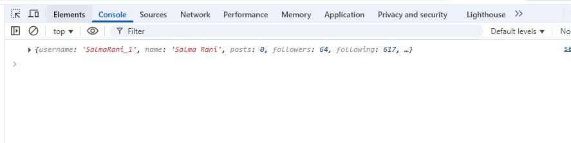

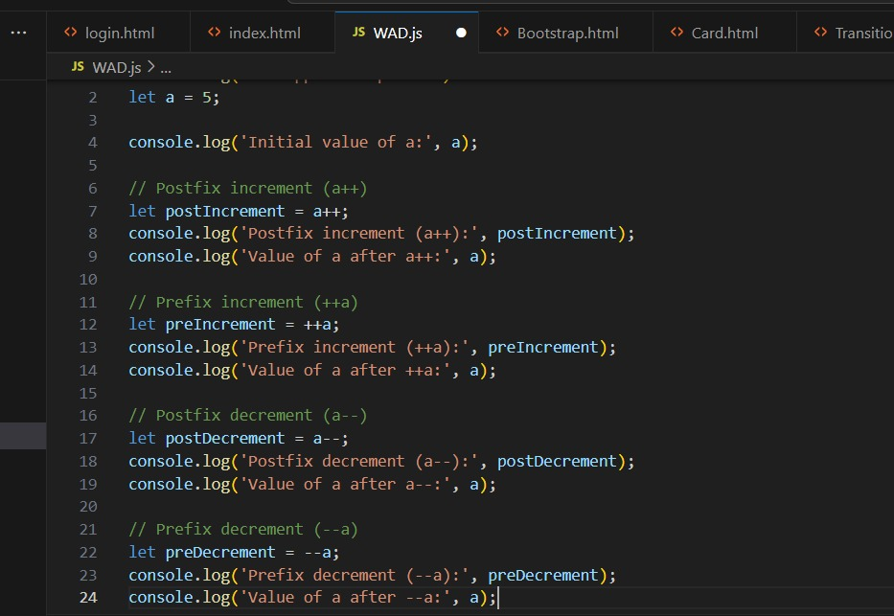**TASK 4**

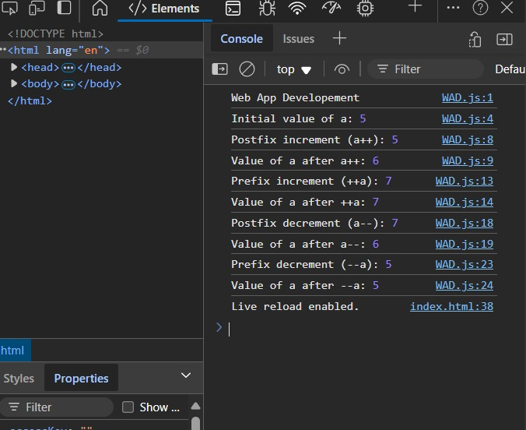

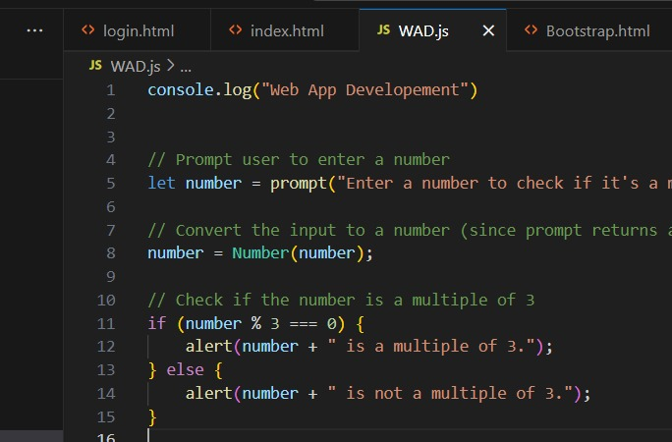**TASK 5**

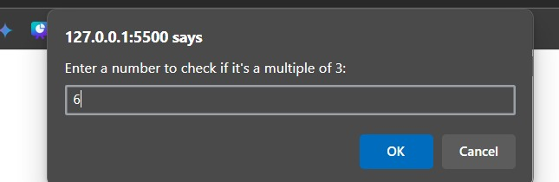

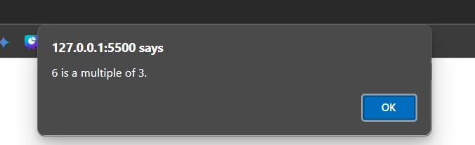

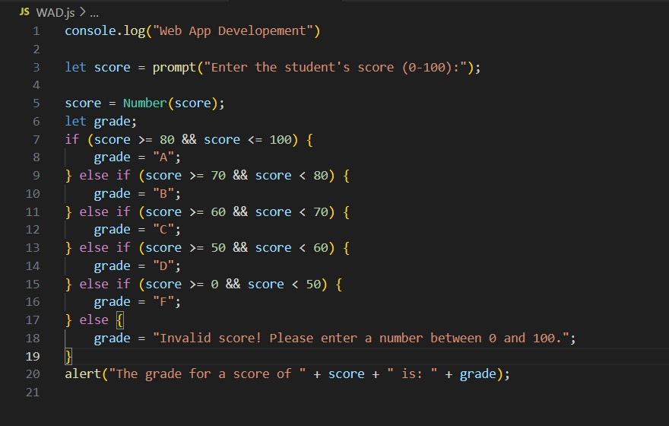**TASK 6**

